**Project**

**Rubber Ducky USB using raspberry pi Pico**

**INTRODUCTION**

The Rubber Ducky USB, also known as a USB Rubber Ducky or simply Rubber Ducky, is a powerful hacking tool that resembles a regular using raspberry pi Pico as USB but operates with a different purpose. It has gained popularity among ethical hackers, security professionals, and enthusiasts due to its ability to automate tasks and exploit vulnerabilities in target systems.

* So in this project I am going to make a rubber ducky USB using raspberry pi pico
* Making a malicious ducky script.
* Inject into our raspberry Pico.
* And then inject into our target system.

**Components**

* Raspberry pi Pico
* Simple Data cable

**WORKING**

* When we attach our with Raspberry pi Pico our operating system.
* Then the payload automatically infects our OS.
* It will act as a keyboard or mouse or other input device so no antivirus detect it.
* When a Raspberry pi pico with a Ducky Script is connected to a computer, it can rapidly input keystrokes, allowing it to automate tasks or exploit vulnerabilities.
* The Ducky Script can execute a sequence of commands to modify system settings, disable security features, or perform other actions to gain unauthorized control over the target computer.
* The script can be designed to silently download and execute malicious files or payloads onto the target computer, such as malware, Payload, or Batch scripts, compromising the system's security.

**Script for Bit locker:**

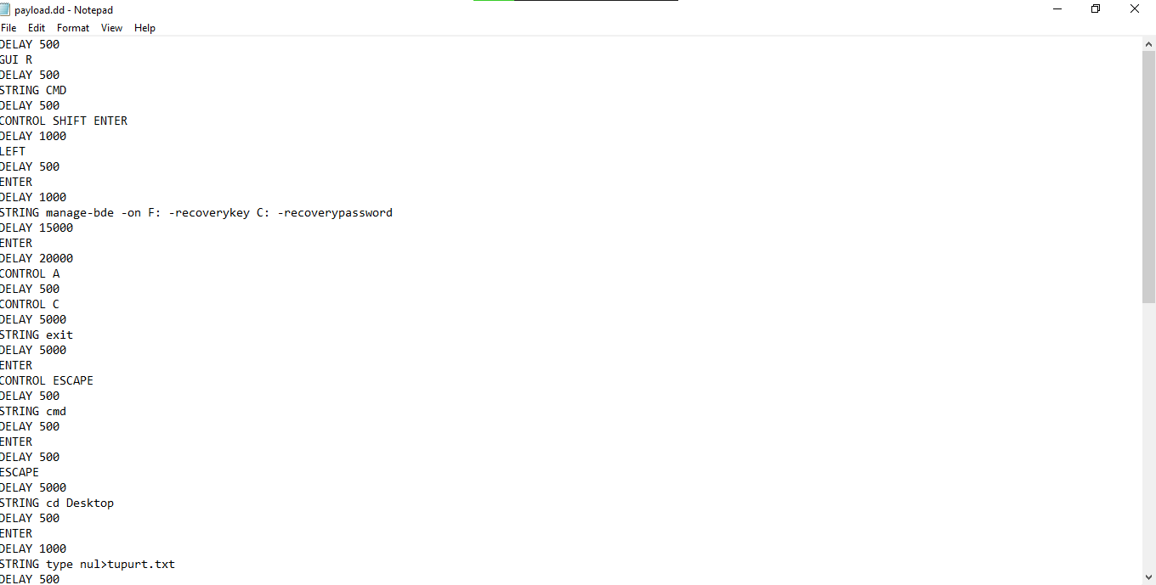

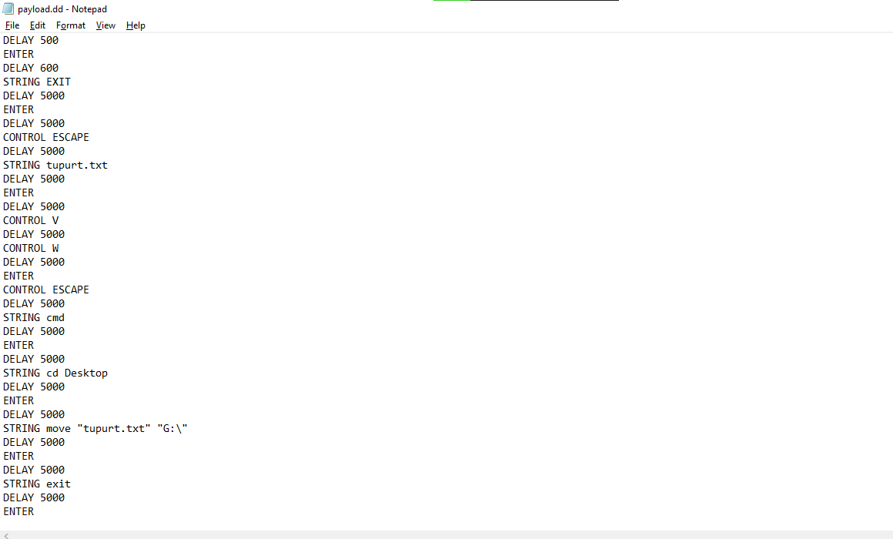

**Payload for firewall**

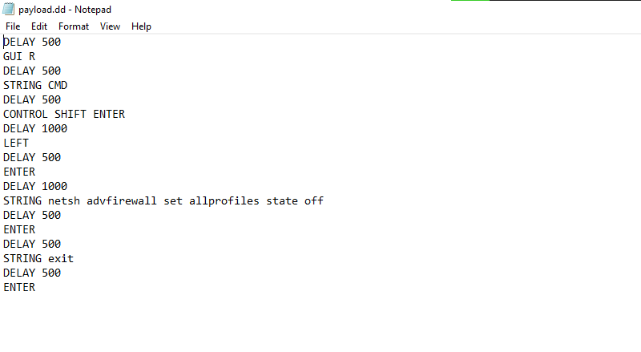

**Payload for task manage**

